1 ) 0 Level-DFD

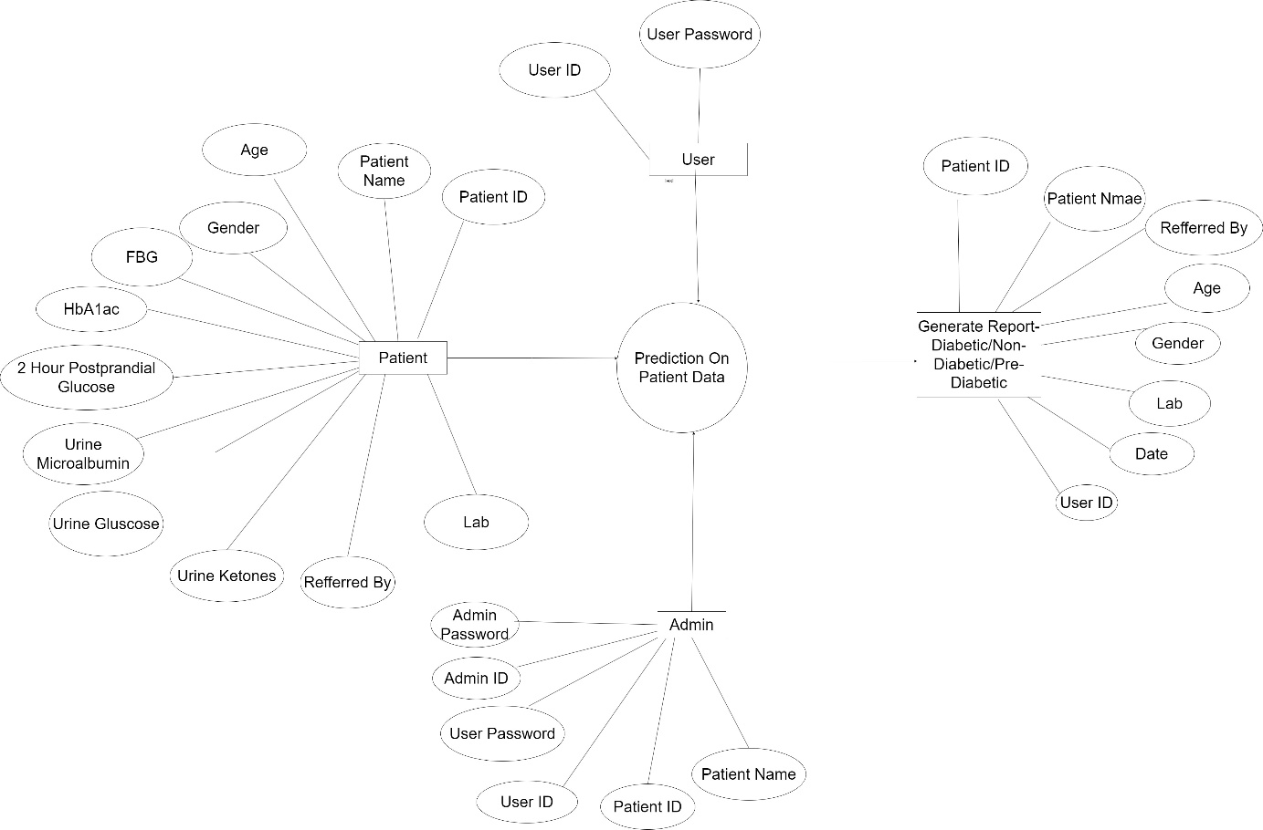

2) ML-Model

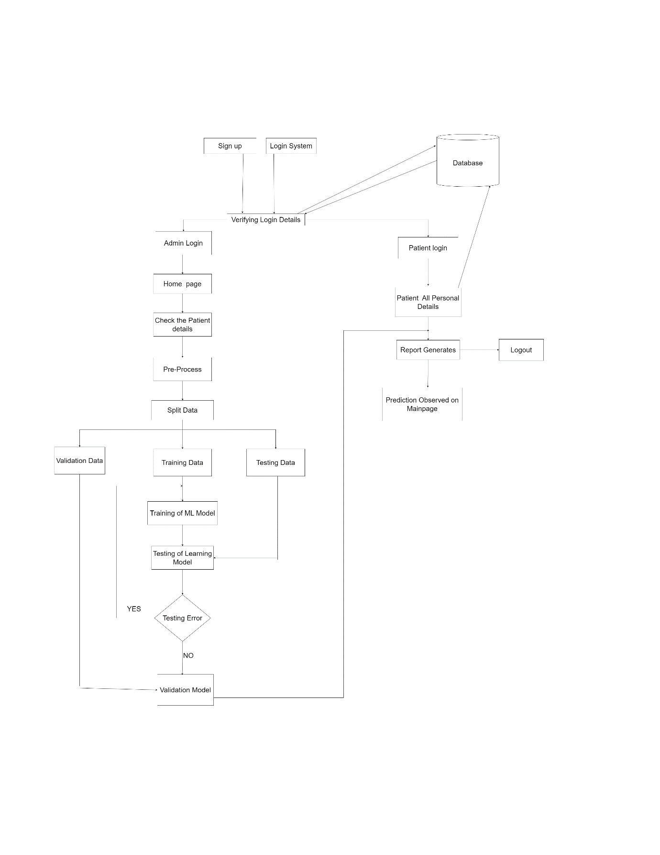

3)Data Model

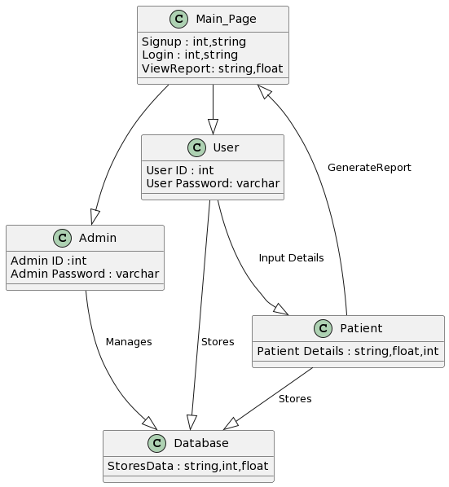

4) Data Structure :

* Admin Login Details :

|  |  |  |
| --- | --- | --- |
| # | ATTRIBUTE | DATATYPE |
| 1 | Admin ID | VARCHAR |
| 2 | Admin Password | VARCHAR |
| 3 | User ID | VARCHAR |
| 4 | User Password | VARCHAR |
| 5 | Patient Id | INT |
| 6 | Patient Name | VARCHAR |
| 7 | Gender | VARCHAR |
| 8 | Age | INT |
| 9 | BMI | FLOAT |
| 10 | FBG | INT |
| 11 | 2 HOUR POSTPRANDIAL  GLUCOSE | INT |
| 12 | HbA1ac | FLOAT |
| 13 | Family History | VARCHAR |
| 14 | **Urine Microalbumin** | FLOAT |
| 15 | **Urine Glucose** | INT |
| 16 | **Urine Ketones** | INT |
| 17 | Lipid_Profile | FLOAT |
| 18 | Blood Pressure | VARCHAR |
| 19 | Physical Activity | STRING |
| 20 | Date | DATE |
| 21 | Referred By | STRING |
| 22 | Lab | STRING |
| 23 | Diabetes Status | STRING |

* User Details:

|  |  |  |
| --- | --- | --- |
| # | ATTRIBUTE | DATATYPE |
| 1 | User ID | VARCHAR |
| 2 | User Password | VARCHAR |

* Patient Details:

|  |  |  |
| --- | --- | --- |
| # | ATTRIBUTE | DATATYPE |
| 1 | Patient Id | INT |
| 2 | Patient Name | VARCHAR |
| 3 | Gender | VARCHAR |
| 4 | Age | INT |
| 5 | BMI | FLOAT |
| 6 | FBG | INT |
| 7 | 2 HOUR POSTPRANDIAL  GLUCOSE | INT |
| 8 | HbA1ac | FLOAT |
| 9 | Family History | VARCHAR |
| 10 | **Urine Microalbumin** | FLOAT |
| 11 | **Urine Glucose** | INT |
| 12 | **Urine Ketones** | INT |
| 13 | Lipid_Profile | FLOAT |
| 14 | Blood Pressure | VARCHAR |
| 15 | Physical Activity | STRING |
| 16 | Date | DATE |
| 17 | Referred By | STRING |
| 18 | Lab | STRING |
| 19 | Diabetes Status | STRING |